Autonomous Driving Assignment

**Submitted By**: Syed Umair Hassan Kazmi

Their are 3 algorithims inside these folders:

* 1 to detect vehicles
* 1 to detect signs
* 1 to detect lanes.

1. Code to detect vehicle and signs are written in one notebook on colab. They should also be opened on colab for proper view.
2. Code to detect lanes are written on local jupyter notebook. They should be opened locally for proper view.

Below are videos and pictures of results of all 3 algorithims.

**Vehicle, Human And Traffic Lights Detection**

Yolov5 algorithim with pre-trained Yolov5s weights were used for this purpose.

Double click to play video

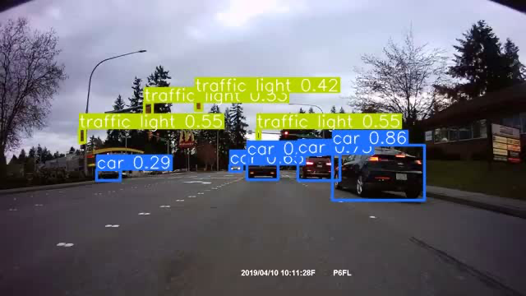

**Signs Detection**

Yolov5 alorigthim was trained on custom dataset imported from kaggle.

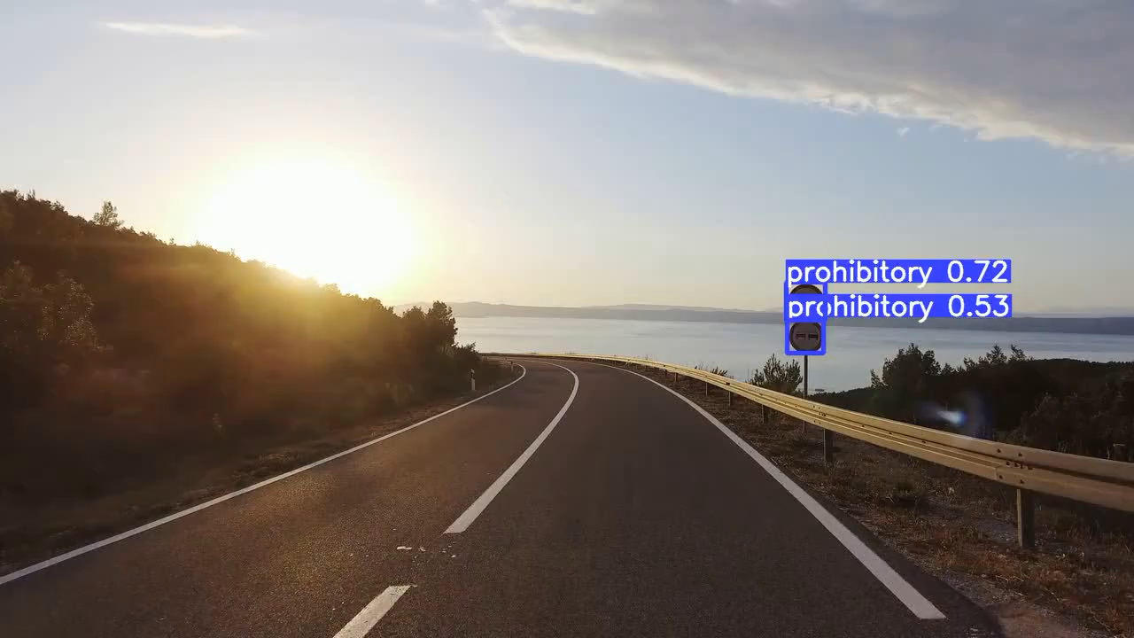Double click to play video

Double click to play video

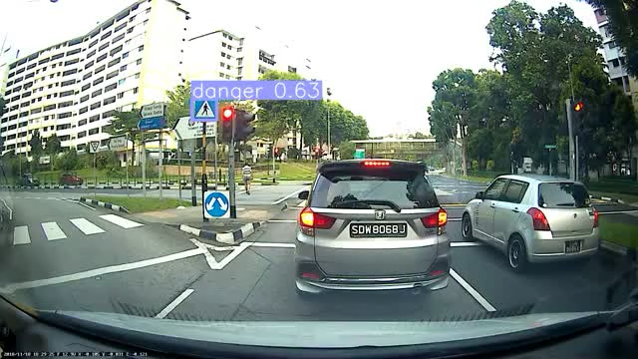

**Lane Detection**

Simple functions were written using cv2 to detect lanes. Altough it detects lanes pretty good, it works only on straight roads and on some videos only.

Double click to play video

